== Trellx Xpand Recap ==

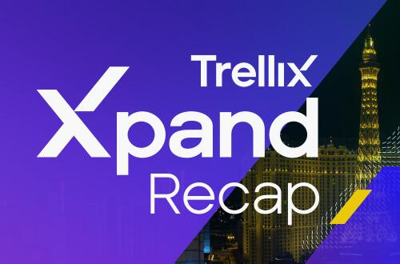

In case you missed attending our cyber security partner @Trellix Xpand LIVE or want to go through any of the Keynotes as well as Breakout sessions to learn about Trellix’s leading XDR platform, here is the link: https://www.trellix.com/en-us/about/events/2022/trellix-xpand-recap.html?eid=KBMYB3R

#TeamTrellix

== Trellx XDR Whitepaper ==

Adapt your cybersecurity approach at the speed of threats. Stay ahead of cyberattacks with data protection, SecOps and analytics, and security for your endpoints, network, email, and cloud. All from our cybersecurity partner, @Trellix. Read the whitepaper to learn more and when you’re ready, let us show you how.

https://www.trellix.com/en-us/assets/whitepapers/taking-control-of-security-operations-whitepaper.pdf?eid=KBMYB3R (Partner: You can either use the link here or download and cobrand the white paper and host it on your own site.)

#TeamTrellix

Accelerate detection and correction throughout the entire defense lifecycle. With an open platform and the largest threat telemetry network, @Trellix XDR is your complete unified multi-layer security solution. Read the whitepaper to learn more and reach out to us to show you how.

https://www.trellix.com/en-us/assets/whitepapers/taking-control-of-security-operations-whitepaper.pdf?eid=KBMYB3R (Partner: You can either use the link here or download and cobrand the white paper and host it on your own site.)

#TeamTrellix

