== Trellix Xpand Recap Recordings ==

Subject: Trellix Xpand Recap

Hello <<customer>>,

We partner with the leaders in various industries. For cybersecurity that leader is Trellix (the company formed from the merger of McAfee and FireEye. Recently they hosted their live customer show called Trellix Xpand Live! It was the best way to learn about what Trellix is all about and their plans for the future. Thankfully, the key notes and many of their sessions were recorded so I wanted to make sure you get access to them.

Click the link below to hear from Trellix executives, including:
- Bryan Palma, CEO, speaking about the Trellix vision, living security, soulful work and what cybersecurity means for the future,
- Aparna Rayasam, CPO, speaking about Xconsole, Unified Endpoint, Cloud, Email, Data, Network, and
- Amol Mathur, SVP Products, speaking about getting to the best possible (Cyber Defense) outcome, Xconsole & Insights, how it works in providing responsive actions against attacks.

In addition, you’ll be able to see the sessions related to the themes of Activating Intelligence, SecOps Revolution, Securing the Ecosystem, Unifying Endpoint, #SoulfulWork and more.

Click the link below to take you to the Trellix Xpand Recap site and login as either an onsite attendee or virtual attendee.

https://www.trellix.com/en-us/about/events/2022/trellix-xpand-recap.html?eid=KBMYB3R

And don’t forget to share it with any of your colleagues so they can learn more about Trellix.

== XDR Infographic ==

Subject: Empower your business with increased SecOps efficiency.

Dear <<customer>>,

In a modern landscape where the complexity of cyber threats evolves quickly, the answer to keeping your data safe lies in using an efficient security infrastructure that continues to learn and adapt.

Extended Detection and Response (XDR) from our cybersecurity partner, Trellix, unifies your security products and tools to simplify your operations and build a solid infrastructure—empowering you to protect your organization in three important ways.

Find out more in this infographic—and explore why so many global organizations are adopting XDR. And let me know when you are ready to start elevating your security.

== White Paper Download ==

Subject: Simplify your Security Operations.

Dear <<customer>>,

As the cyber security threat landscape evolves, businesses need better ways to improve their security posture and stay one step ahead in data protection. According to a report by Gartner, 75% of large organizations will be actively pursuing a security vendor consolidation strategy by 2025.

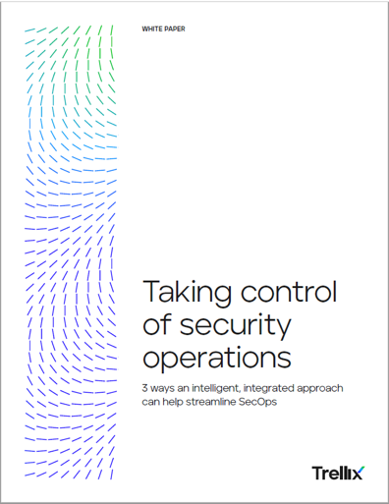 | Read the white paper “Taking Control of Security Operations” by our cybersecurity partner Trellix and discover three ways you can use an intelligent, integrated, unified approach to streamline your SecOps.  With this more holistic approach, your business can increase operational efficiencies, adapt to new threats, and embed security into your organization’s DNA.  Download the white paper to learn more and let me know how we can help you take control of your security operations.

== Multi Utility Provider Case Study ==

Subject: Reinforce security defenses with Trellix.

Dear <<customer>>,

When a multi-utility provider realized how difficult it would be for their small team to respond to potential cyber-attacks, they quickly prioritized their security posture. They traded in multiple security products sourced from different vendors and instead chose one partner for their new security solutions: Trellix.

With Trellix, this provider of utilities for small to mid-sized communities across North America streamlined their security and got deep visibility into every endpoint across their threat vectors. They used Trellix’s experts as an operational extension of their team to fortify their security posture.

Download this case study and explore how this industry leader used Trellix’s unifying portal to strengthen and manage their security environment—while protecting valuable customer data. And let me know if you are interested in learning how you can protect your data with Trellix.

