Protect and Recover

From Threats Campaign
  - Organic Social Media Posts
November 2021

Social Media Sheet: Protect and Recover from Threats — Twitter and LinkedIn

To be used on TWITTER or LINKEDIN | Content - Use these samples as a starting point to develop your own original tweets. Tweets can be no longer than 280 characters in length, including spaces, hashtags and short links.
CTA: Feature Demo You Are in Control: Securing your data management environment with Commvault | With new strains of #ransomware and other malware threats on the rise, your enterprise and customer data is continually at risk despite the steps you have taken. Learn how #Commvault can help: http://ow.ly/Xpme50GuNyy
 | We need to talk about another "R" when it comes to #ransomware: Reinfection. Avoid being hit again with #Commvault http://ow.ly/Xpme50GuNyy
 | #DYK that the #Commvault Command Center user interface is fully customizable? Giving the ability to have role based views and role based access view. http://ow.ly/Xpme50GuNyy #CommvaultTips #RansomwareProtection #DataProtection
 | DEMO ALERT!!! #Ransomware reinfection - a very real threat that every enterprise needs to mitigate against. Find out how #Commvault surgically delete suspicious files https://bit.ly/2ZNbc9g
 | Let's talk #ransomware - not just detection or recovery but specifically how to avoid reinfection. In fact – let us show you how #Commvault safeguards your #data against this growing threat http://ow.ly/Ed4J50FclDB
Image | 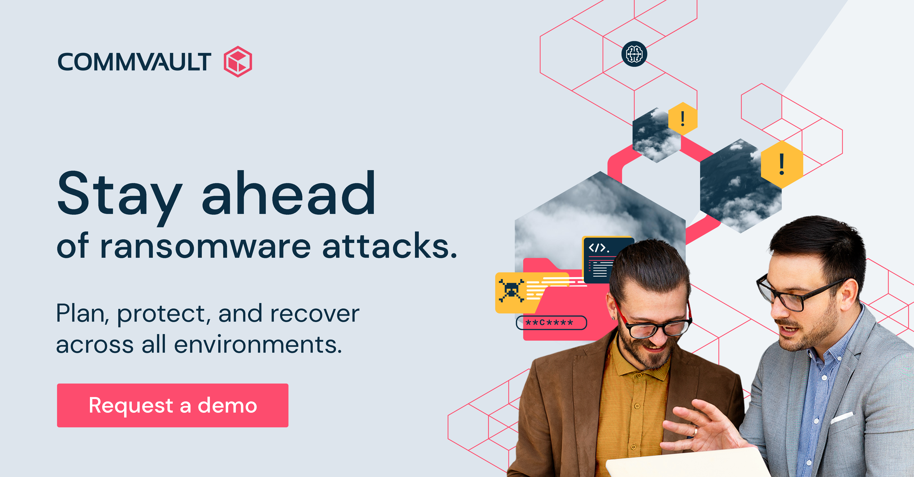
CTA: Infographic  The multi-layered approach to data protection and recovery | Security-conscious organizations trust #Commvault on data recovery to get businesses back up and running in no time. See our multi-layered approach all in one place: https://bit.ly/3ugTcRk http://ow.ly/Ed4J50FclDB
 | Our main goal? Providing you with the best recovery capabilities. See how to reduce #cybersecurity risk and ensure #data availability through our secure backup framework: https://bit.ly/3ugTcRk
🔬Identify
🛡️Protect
🔎Monitor
💬Respond
⛑️ (if needed) Recovery.
Follow our 5 step framework to #ransomware prevention & tailor your plan by quickly talking it out with a human https://bit.ly/3ugTcRk
 | #Commvault provides a multi-layered security framework built on Identify, Protect, Monitor, Respond, and Recover—Learn why Commvault has the most robust ransomware recovery security features in the market today https://bit.ly/3ugTcRk
 | Reduce cybersecurity risk and ensure data availability through Commvault’s secure backup framework. This end-to-end framework consists of features sets, guidelines, and best practices. Learn more about Commvault Ransomware Protection and Recovery Framework https://bit.ly/3ugTcRk
Image | 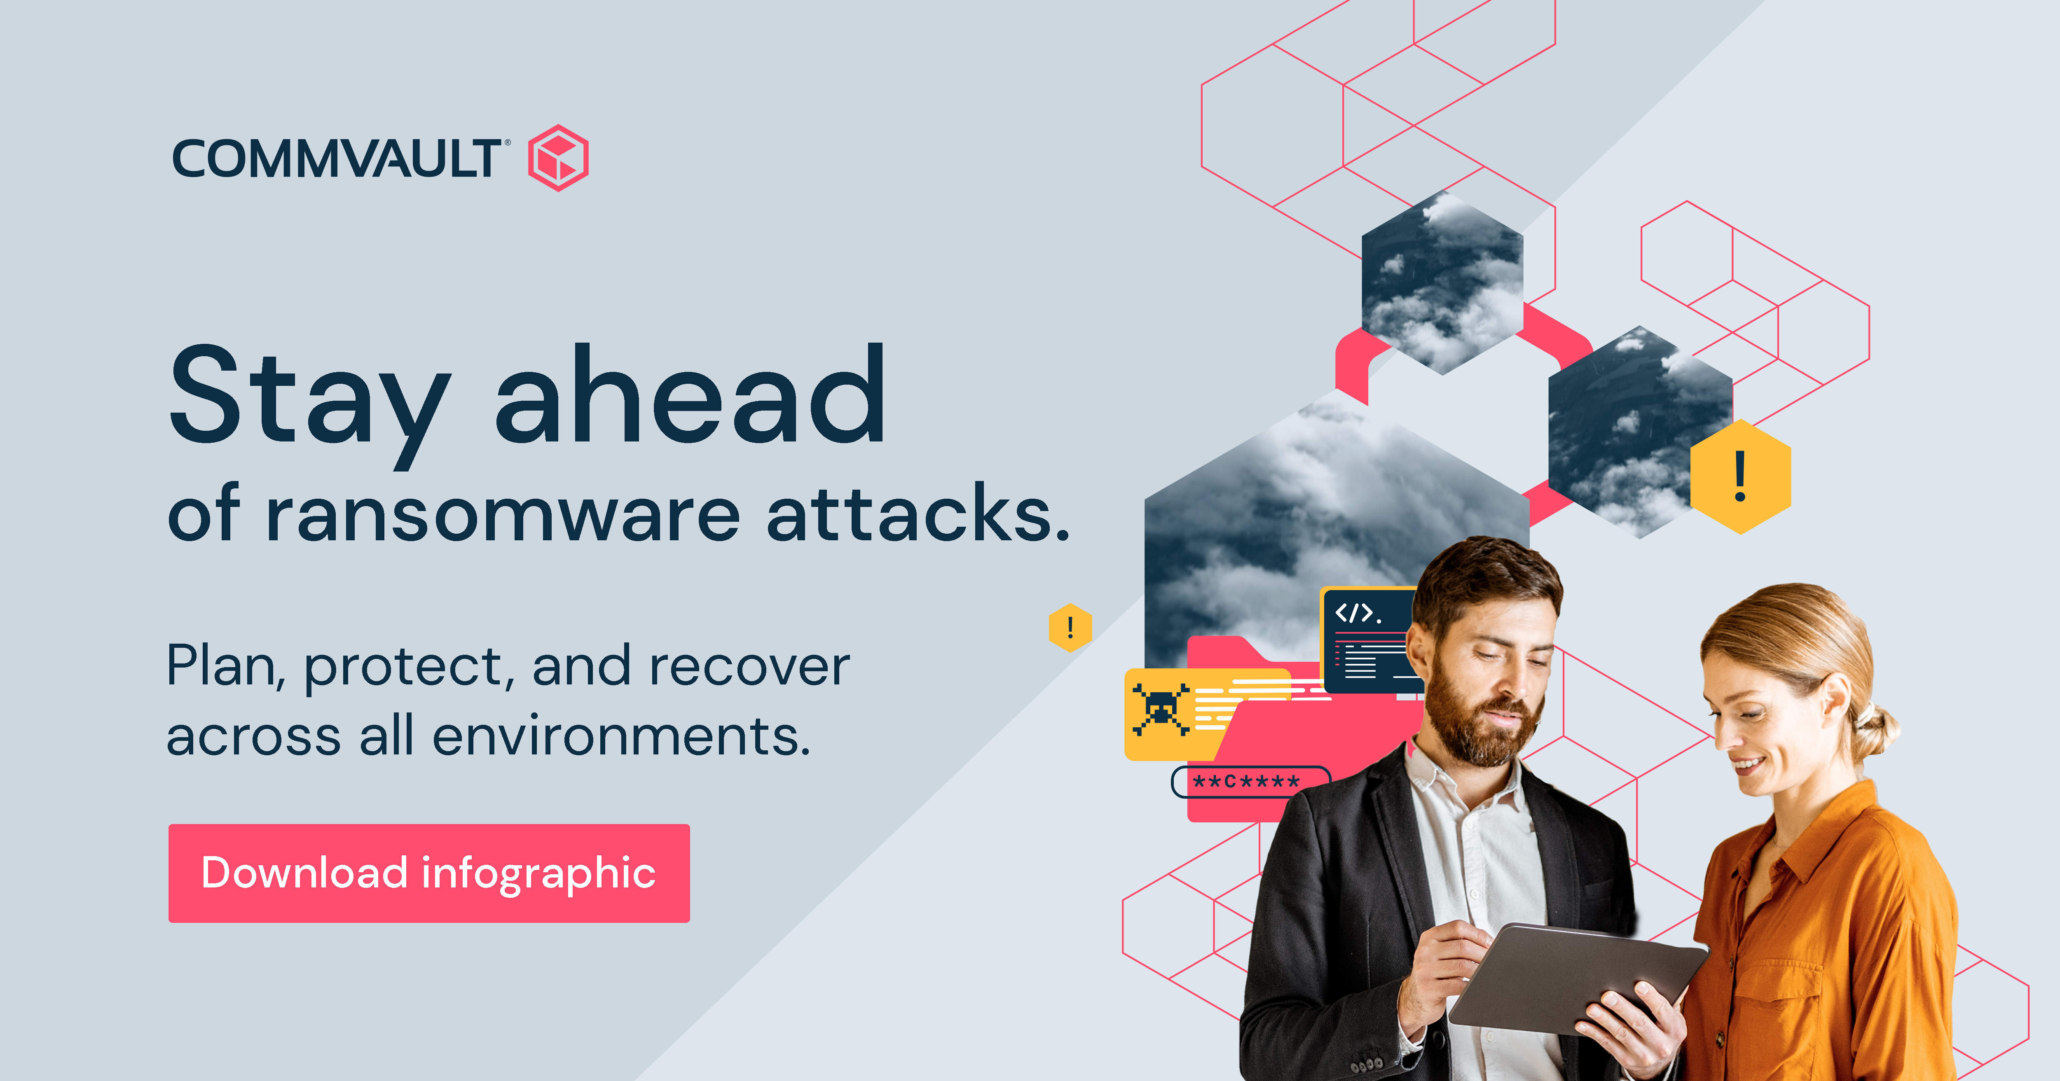
CTA: Whitepaper  Protect, detect, and recover from ransomware – quickly and fully | The bad news? #Ransomware happens. The good news? It's what you do next that counts. Learn how #Commvault provides an end-to-end solution that improves threat and risk mitigation across all endpoints and applications. http://ow.ly/lV2P50GuVLg
 | Commvault helps protect against ransomware and other threats by making it harder for hackers to launch a successful attack, and mitigating the impact of any malware that enters your environment. Learn how #Commvault can help http://ow.ly/lV2P50GuVLg
 | DYK that by 2025, 75% of IT organizations will have faced one or more #ransomware attacks? See how #Commvault protects your data with immutable architecture, infrastructure hardening & much more http://ow.ly/lV2P50GuVLg
 | The costs of #ransomware attacks can be astronomical 🛰️ keep your #dataprotection grounded with #Commvault Ransomware Protection and Recovery solutions. Find out more here: http://ow.ly/lV2P50GuVLg
 | Introducing #Commvault #Ransomware Protection and Recovery solutions - a powerful weapon in the fight against cyber criminals. Learn more http://ow.ly/lV2P50GuVLg
Image | 