HPE ProLiant DL325 Gen10 Server
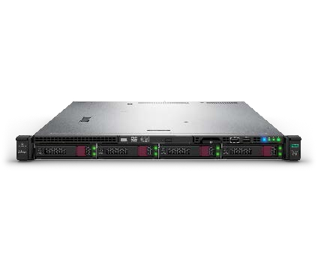
HPE ProLiant DL325 1P 1U delivered an astounding 321%1 performance boost over the previous record holder, providing a significant agility advantage in database provisioning and maintenance for cloud, big data and IoT environments.

HPE ProLiant DL385 Gen10 Server
The HPE ProLiant DL385 2P 2U with two 2nd Gen AMD EPYC™ processors crushed the previous virtualization world record with 61 percent better performance2 and at a 29 percent better price to
performance ratio₃.

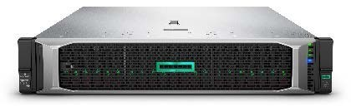

Why upgrade to HPE ProLiant Gen10 servers?
Enjoy a new compute experience with the HPE ProLiant Gen10 portfolio, delivering:
- Agility to deliver business results
- Security to better protect your business and data
- Economic control for consumption and to pay for only what you use
The HPE-exclusive silicon root of trust has already made the HPE ProLiant the world’s most secure industry standard server. Now, with the integration of the new AMD EPYC™-embedded Secure Processor into the HPE silicon root of trust, protection is even more complete than before.
HPE ProLiant Gen10 servers help accelerate business results with faster compute, memory, and I/O performance, as well as storage, networking, management, and security advancements.
The breadth of the HPE ProLiant Gen10 portfolio is optimized for various workloads including IT infrastructure (file/print), web (web serving), business applications (ERP and CRM), collaboration (email and unified communications), analytics and Big Data (scientific/engineering), and more

Resources

HPE AMD
hpe.com/partners/amd HPE promotional programs hpe.com/us/prolianttradein HPE security hpe.com/security

5 1 TPC Express Benchmark™ V – 1P Performance as of August 7, 2019
- SPEC VIRT_SC 2013. SPEC and SPEC VIRT_SC are registered trademarks of the Standard Performance Evaluation Corporation (SPEC). All rights reserved, see spec.org as of August 7, 2019.
- None-rebate price from lenovo.com and HPE as of July 16, 2019.

HPE ProLiant Shatters World Records!
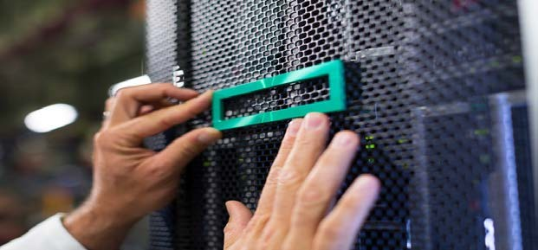
HPE ProLiant Gen10 Servers. The right product at the right price, right now. Check out our NEW! AMD Smart Buy Express offers.
Available for customer orders starting Aug 26. Contact your SYNNEX sales rep for promotional pricing through October 31,2019.
.

DL385 Gen10 Server |  | DL385 Gen10 Server |  | DL385 Gen10 Server
P16690-B21 |  | P16692-01 |  | P16693-B21
AMD 7262 8c (1); 0 HDD |  | AMD 7262 8c (1); 0 HDD |  | AMD 7452 32c (1); 0 HDD
(up to 12LFF); 1x16GB DDR4; |  | (up to 8SFF); 1x16GB DDR4; |  | (up to 24SFF), 1x16GB DDR4,
1x 800W PS; P816i-a SR |  | 1x 800W PS, P408i-a SR |  | 1x800W PS; P408i-a SR
DL385 Gen10 Server |  | DL325 Gen10 Server |  | DL325 Gen10 Server
P16694-B21 |  | P17199-B21 |  | P17200-B21
AMD 7302 16c (1); 0 HDD (up to 8SFF); 1x16GB DDR4; 1x 800W PS ;P408i-a SR |  | AMD 7262 8c (1); 0 HDD (up to 4LFF); 1x16GB DDR4; 1x800W PS; S100i |  | AMD 7262 8c (1); 0 HDD (up to 8SFF); 1x16GB DDR4; 1x 500W PS; P408i-a SR
DL325 Gen10 Server DL325 Gen10 Server

P17201-B21
AMD 7302P 16c (1); 0 HDD (up to 8SFF); 1x16GB DDR4; 1x800W PS; P408i-a

P16696-B21
AMD 7402P 24c (1); 0 HDD (up to 8SFF); 2x 32GB DDR4; 1x800W PS;P408i-a

Call to Action
Contact your SYNNEX Business Development team (HPE@synnex.com) for more information and your SYNNEX sales rep to place your orders!

© Copyright 2019 Hewlett Packard Enterprise Development LP. The informationcontainedherein is subject to change withoutnotice. The only warranties for Hewlett Packard Enterprise products andservices are set forth in the express warrantystatements accompanyingsuch productsand services. Nothingherein shouldbe construed as constitutingan additionalwarranty. Hewlett Packard Enterpriseshall not be liable for technical or editorial errors or omissions contained herein. This document containsconfidential and/or legally privileged information. It is intended for HPE and Channel Partner Internal Use only. If
you are not an intended recipient as identified on the front cover of this document, you are strictly prohibitedfrom reviewing, redistributing, disseminating, or in any other way usingor relying on the contents of this document.
Intel and Xeon are trademarksof Intel Corporationor its subsidiaries in the U.S. and/or other countries. Microsoft, Windows Server, and SharePoint are either registered trademarks or trademarksof Microsoft Corporationin the United States and/or other countries.
June 2019

